- After Keith Lee Grant filed his first complaint with the Office of Affirmative Action, Compliance, and Diversity he was denied the opportunity to direct/choreograph in the City College of New York [CCNY] Theatre Department Season seven times since 2011
  - Directing productions in the season professionally, creatively and socially connected Grant to the Department faculty members, students, designers, technicians and the staff
  - Directing productions in the CCNY season gives faculty members exposure on campus to faculty, staff, and college administrators who might attend or hear about her/his productions
  - Grant was not allowed to direct in the following CCNY Theatre Department seasons after filing his 2011 Racial Discrimination Complaint
    - 2011, 2012, 2013, 2014, 2018, 2019, 2020 and 2021
    - The other faculty directors, (Jennifer Tuttle and David Willnger) have never been removed from a season.
  - Grant was removed from the 2017-18 season. He was not allowed to direct THE COLORED MUSEUM. The College brought in an adjunct/guest director to direct in the slot that was assigned to Grant.
    - Grant was never told why he was removed from the directing pool.
    - Below is the email in which Professor Barron removed Grant from directing THE COLORED MUSEUM.
    - Please note that this has never happened to anyone who was assigned a directing slot.

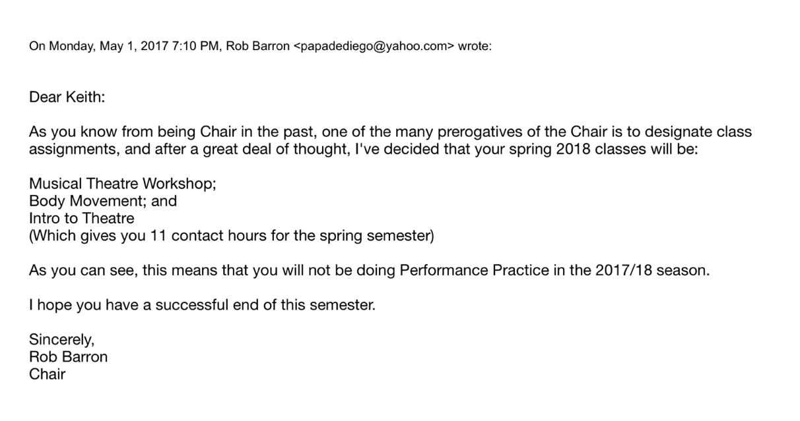

  - Grant was removed from the 2019-20 directing pool via email
  - Grant was given no reason (see e-mail below) why he would not be working in 2019-20 while the other two faculty directors, (Tuttle and Willinger) were given directing slots.

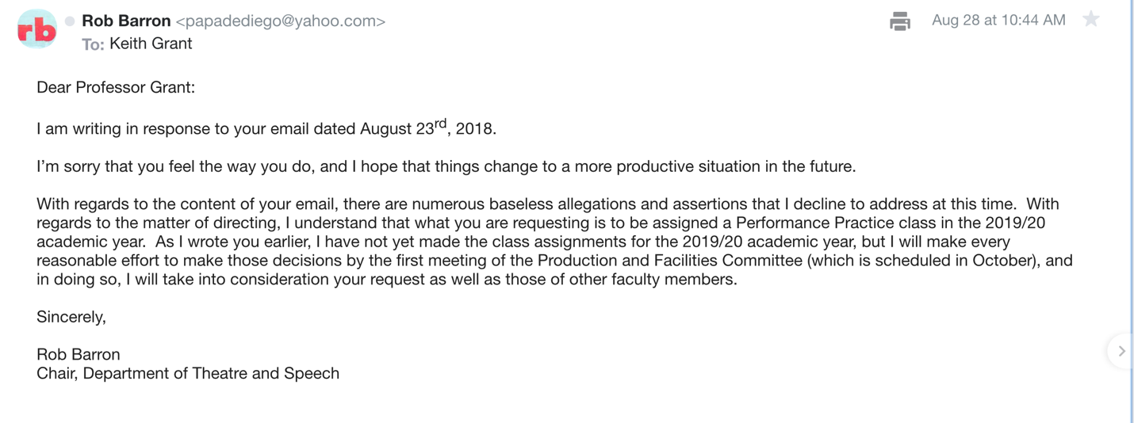
When Barron made his final decision – Grant was NOT directing in the 2019-20 CCNY Theatre Department season.

Barron wrote on October 9, 2018:

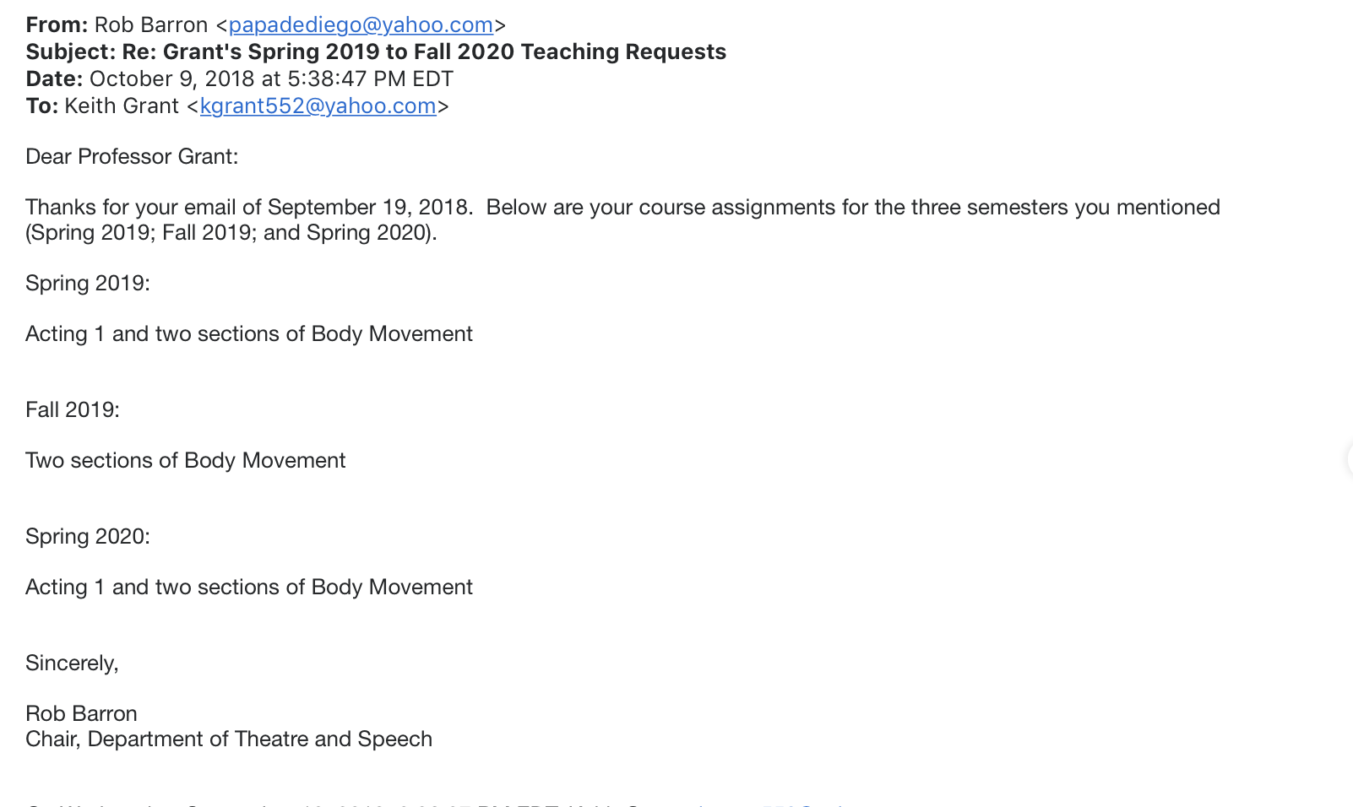

- Since 2009, Grant has proposed productions to the Production and Facilities Committee for their consideration but all of his proposals were rejected.
  - Grant submitted a proposal to direct and choreograph new one-hour adaptations of FINIAN'S RAINBOW/FLAHOOLEY in the December slot of the CCNY Theatre Department's 2013-14 Season.
  - The Yip Harburg Foundation offered to help fund these productions.
  - The Production Committee never communicated with Grant about his proposal.
  - The Committee ignored Grant.

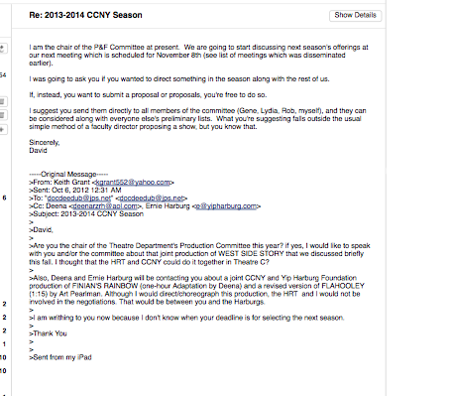

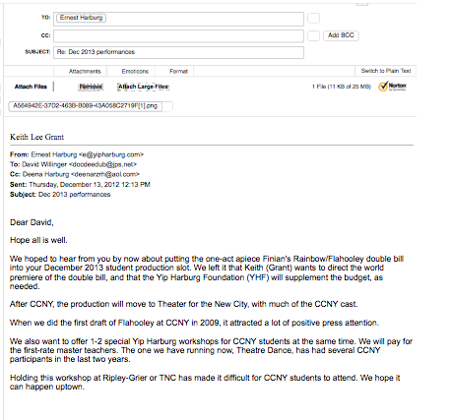

  - Grant submitted a formal proposal to direct and choreograph, WEST SIDE STORY (WSS) for the CCNY Theatre Department's Fall 2012 season but rescinded the offer because the Production Committee did not respond.

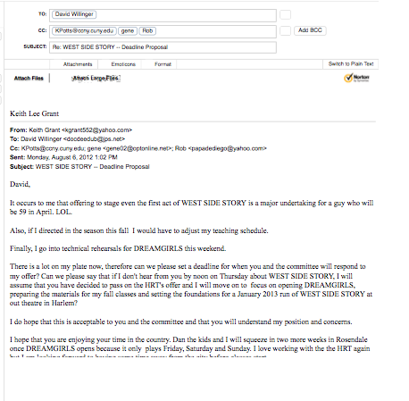
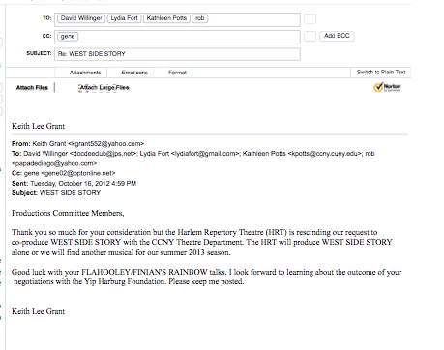
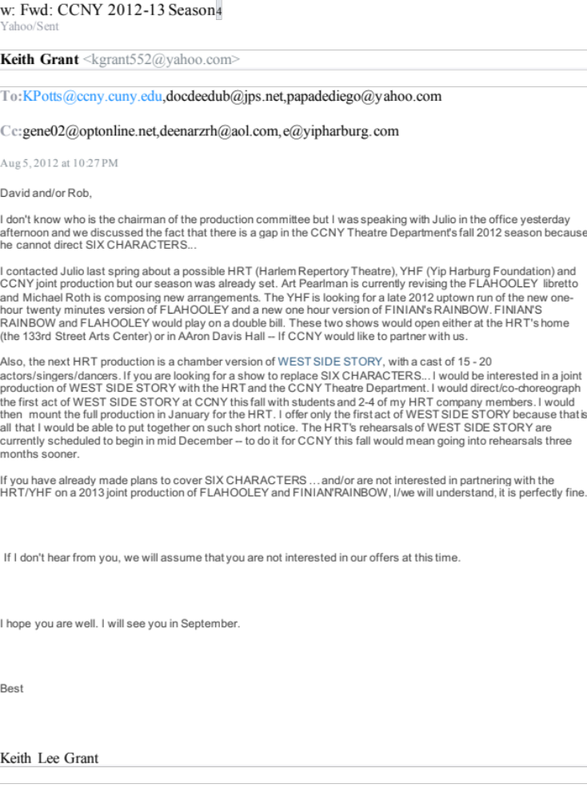

- In an attempt to discourage Grant from directing in the CCNY Theatre Department season, the selection of his productions was often delayed by the Productions Committee Members
  - Other director’s productions were selected in minutes or sometimes seconds.
  - Grants productions were confirmed after 6-8 months of deliberations.

- It took almost 8 months for the Productions Committee to decide on Grant’s production of, JAMAICA while the other Professor’s productions were selected in minutes.
- Grant submitted his requests to direct in the 2018-19 season in September 2016 but did not get a response until April 2018
- On February 17th 2016 Grant checked in with the Productions Committee to ask why selecting my show was being delayed

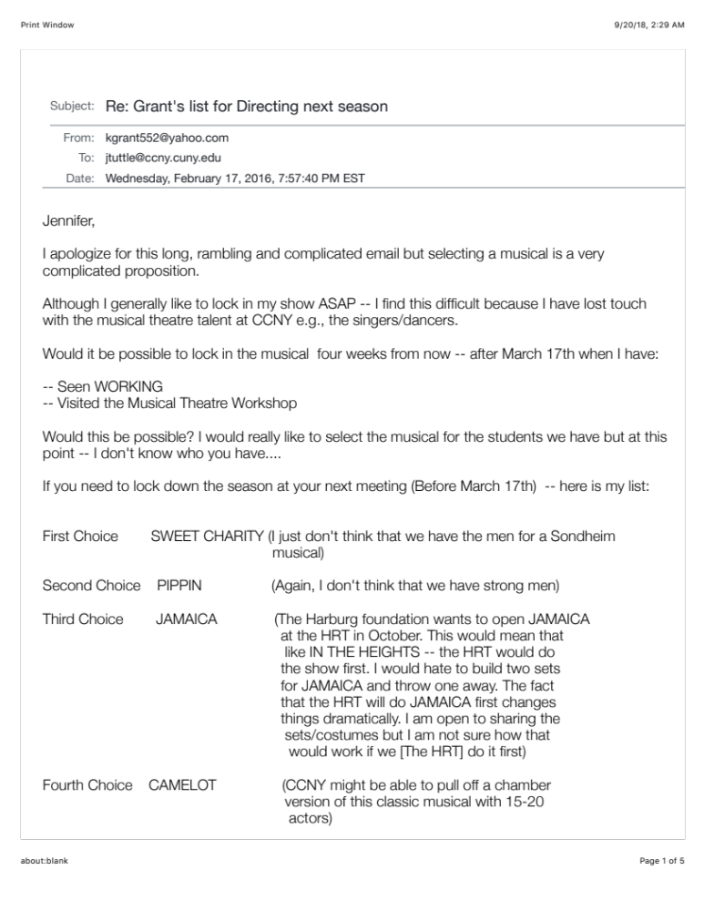

- On April 14th, 2017 Grant wrote to the Committee again, asking why the decision about my production was being held:

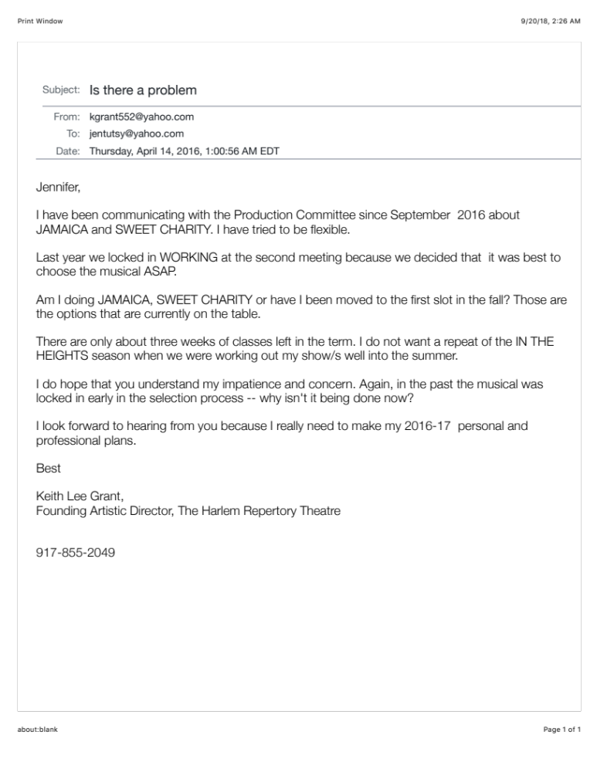

- Grant wrote again to the Committee Chairman, (Jennifer Tuttle) on April 14th at 1:54PM
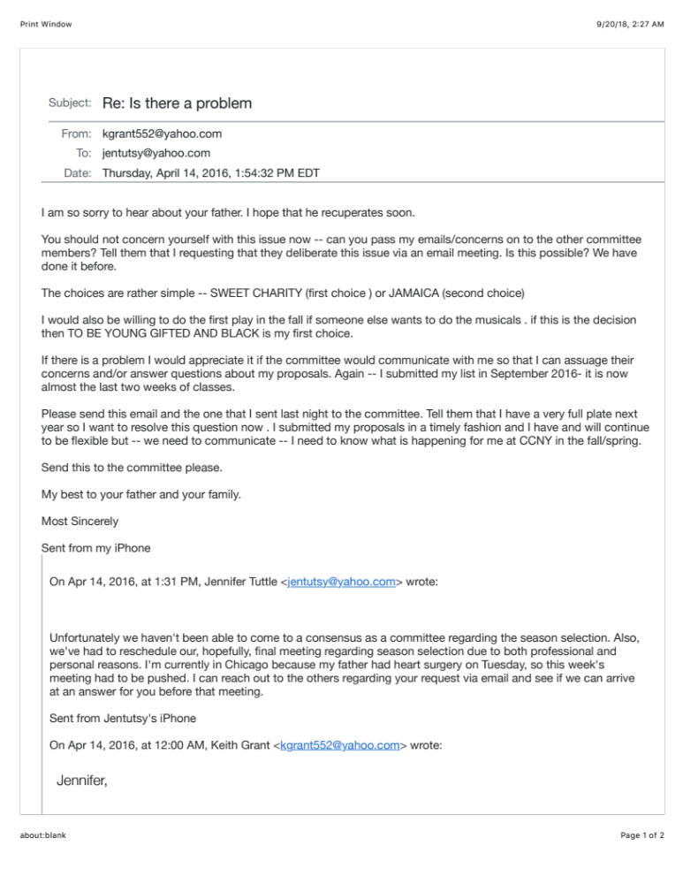

- After he filed his first complaint with the Office of Affirmative Action, Compliance and Diversity Grant was denied the opportunity to serve in any administrative positions and/or as the Chairman of Departmental Committees.
  - Please note the chart entitled, “Grant’s Faculty Assignments” in which his committee assignments and administrative duties suddenly stop in the Fall of 2009 when he first complained about Barron’s Early Promotion/Tenure and reaches out to The Office of Affirmative Action, Compliance and Diversity.
  - In 2013 and 2014 Grant asked to serve as the Department’s Deputy Chairman but was denied when Barron (The Chairman) appointed Jennifer Tuttle to the position even though she was a first year Assistant Professor while Grant had seniority and a higher rank.

